A243 Afr-Egy-Ushabti-Saite Period, 26th Dynasty, 664–525 BCE-blue faience

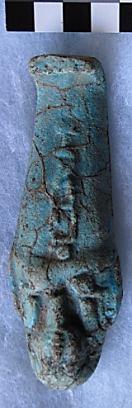

Fig. 1. Ushabti-Saite Period, 26th Dynasty, 664–525 BCE-blue fa

**Case No.: 2**

**Formal Label:** Ushabti-Saite Period, 26th Dynasty, 664–525 BCE-blue fa

**Display Description: Hands crossed right over left, unsleeved. Saite plain lappet wig with plain beard.**

**LC Classification:** DT62

**Date or Time Horizon:** Saite Period, 26th Dynasty, 570–525 BCE, Reign of Amasis

**Geographical Area: Sais, Egypt**

**Map, GPS Coordinates:** 30.96650 30.76751, 30º57'59.41" N 30º46'3.02" E

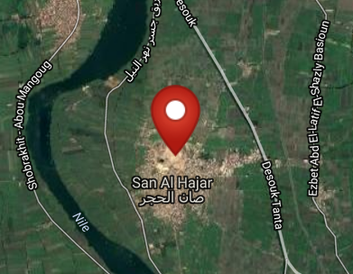 

Fig. 2. Left. Sais on the Nile after http://latitude.to/lat/30.96606/lng/30.76785. Fig. Sais reconstructed according to Jean-Claude Golvin, http://jeanclaudegolvin.com/sais-2/.

**Cultural Affiliation:** Saite Period, 26th Dynasty, 570-525 BCE

**Medium:** blue faience

**Dimensions: H 126.13 mm; 4.96 in  
Weight: 104 gm; 3 5/8 oz**

**Provenance:**

**Condition:**

**Discussion:** Psamtik I, ruled 664–610 BCE, commanded a loose confederation of twelve Egyptian territories, based on the traditional nomes or territories (spAt, in Egyptian), and the rise of Psamtik I in power, establishing the Saitic Dynasty, which is recorded in Herodotus's *Histories* (Bk II: ll. 151–157). Twenty local princelings were appointed by Esarhaddon (king of the Neo-Assyrian Empire who reigned 681 – 669 BCE) to govern Egypt. This Ushabti therefore confirms his allegiance to Psamtik I and not the Neo-Assyrian Esharhaddon.

**References:**

Aubert, J.-F. et L. Aubert. 1974. *Statuettes Egyptiennes: Chaouabtis, Ouchebtis.* Paris, 1974), p. 217, 234, 279-281;

Janes, Glenn. 2002. *Shabtis. A Private View, Ancient Egyptian Funerary Statuettes in European Private Collections.* Paris: Cybèle.

Newberry, Percy E. 1930-1957. *Funerary Statuettes and Model Sarcophagi*.  Le Caire: Impr. de l'Institut français d'archéologie orientale.

Schneider, Hans D. 1977. *Shabtis - An Introduction to the History of Ancient Egyptian Funerary Statuettes. With a Catalogue of the Collection of Shabtis in the National Museum of Leiden*. (3 volumes, Leiden: Rijksmuseum van Oudheden Te Leiden.

Schlögl, Hermann and Andreas Brodbeck. 1990. *Ägyptische Totenfiguren aus öffentlichen und privaten Sammlungen der Schweiz.* Orbis Biblicus et Orientalis, Series Archeologica, 7. Göttingen, Vandenhoeck & Ruprecht; Freiburg Schweiz, Universitätsverlag.